**Bangladesh University of Engineering and Technology**

**Department of Electrical and Electronic Technology**

**EEE 428**

**Measurement and Instrumentation Laboratory**

**Experiment 2**

High Resistance Measured by Loss of Charge Method

Name: Md Maisoon Rahman

Student ID: 1606038

Level: 4, Term: 1

Dept. EEE

**Measurement and Instrumentation Laboratory**

**EEE 428**

Experiment No :02

Experiment Title : High Resistance Measured by Loss of Charge Method

# Objective of the experiment

Using the Loss of charge method to determine the high resistance values.

# Experimental Setup:

The following circuit was implemented in Tinkercad for the experimentation.

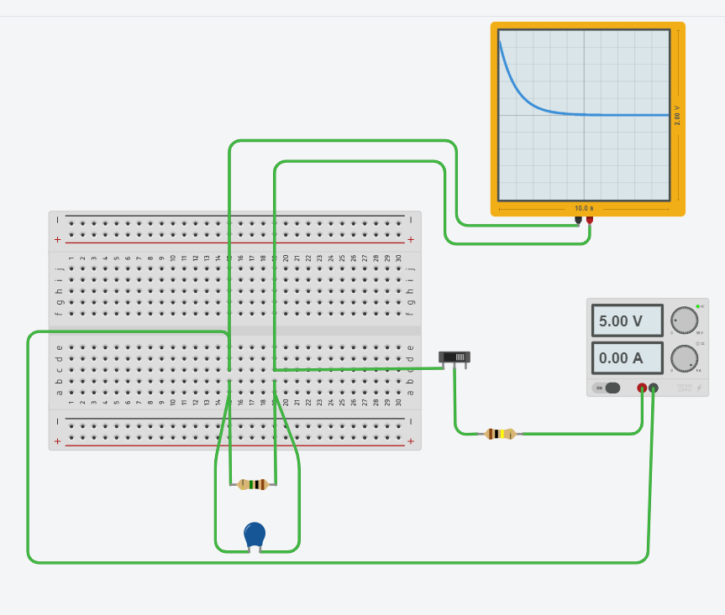

Figure Tinkercad Implementation

Here, instead of a normal multimeter, we used a oscilloscope as that shows the time of voltage discharge, which is crucial for out calculation.

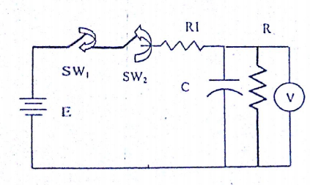

Figure Schematic diagram

In our tinkercad simulation,

at first we observed the output for the following parameters :

C= 1uF

R = 1M Ohm

R1 = 100 kOhm

Then, we observed the performance for the following parameters :

C = 10uF

Then we changed the resistance to :

R = 2, 4, 10 M ohm

The following Observations were obtained :

# CASE 1 (1 uF , R = 1M Ohm, R1 = 100 k Ohm)

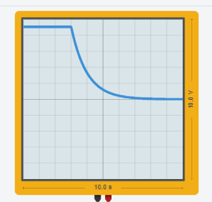

The Capacitor took almost 5s to discharge .

The following table was obtained :

|  |  |
| --- | --- |
| Time | Voltage across C |
| t=0s | 4.54 V |
| 1s | 1.5 V |
| 2s | 0.75 V |
| 3s | 0.25V |
| 4s | 0.05 V |
| 5s | 0.2 mV |

Calculating, R = t / [c log (E/V)]

= 1.147 M Ohm

# CASE 2 (10uF , R = 1M Ohm, R1 = 100 k Ohm)

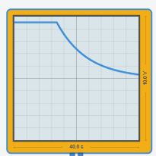 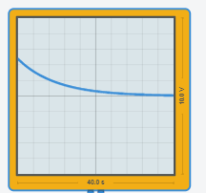

The Capacitor took almost 5s to discharge .

The following table was obtained :

|  |  |
| --- | --- |
| Time | Voltage across C |
| t=0s | 4.54 V |
| 1s | 3.5 V |
| 2s | 3 V |
| 3s | 2.4 V |
| 4s | 2 V |
| 5s | 1.6V |
| 6s | 1.2V |
| 7s | 1V |
| 8s | 0.8V |
| 9s | 0.7V |
| 10s | 0.5V |

Calculating, R = t / [c log (E/V)]

= 1. 043 M Ohm

# CASE 3 (1uF , R = 2M Ohm, R1 = 100 k Ohm)

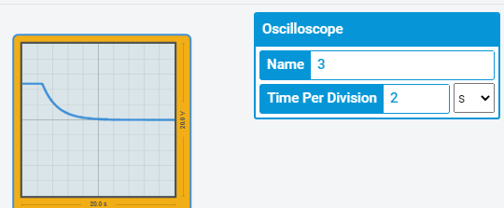

The Capacitor took almost 5s to discharge .

The following table was obtained :

|  |  |
| --- | --- |
| Time | Voltage across C(V) |
| t=0s | 4.54 |
| 1s | 2.5 |
| 2s | 1.5 |
| 3s | 1 |
| 4s | 0.6 |
| 5s | 0.4 |
| 6s | 0.2 |
| 7s | 0.1 |
| 8s | 50mV |
| 9s | 25mV |
| 10s | 0.05mV |

Calculating, R = t / [c log (E/V)]

= 2.01 M Ohm

# CASE 4 (10uF , R = 2M Ohm, R1 = 100 k Ohm)

 

The Capacitor took almost 5s to discharge .

The following table was obtained :

|  |  |
| --- | --- |
| Time | Voltage across C(V) |
| t=0s | 4.54 V |
| 2s | 3.5 V |
| 4s | 3 V |
| 6s | 2.4 V |
| 8s | 2 V |
| 10s | 1.6V |
| 12s | 1.2V |
| 14s | 1V |
| 16s | 0.8V |
| 18s | 0.7V |
| 20s | 0.5V |

Calculating, R = t / [c log (E/V)]

= 2.086 M Ohm

# CASE 5 (1uF , R = 4M Ohm, R1 = 100 k Ohm)

 

The Capacitor took almost 5s to discharge .

The following table was obtained :

|  |  |
| --- | --- |
| Time | Voltage across C(V) |
| t=0s | 4.54 |
| 2s | 2.5 |
| 4s | 1.5 |
| 6s | 1 |
| 8s | 0.6 |
| 10s | 0.4 |
| 12s | 0.2 |
| 14s | 0.1 |
| 16s | 50mV |
| 18s | 25mV |
| 20s | 0.05mV |

Calculating, R = t / [c log (E/V)]

= 4.003M Ohm

as it was more convenient to take the readings with more time per division, we took the reading upto 20 s

# CASE 6 (10uF , R = 4M Ohm, R1 = 100 k Ohm)

 

The Capacitor took almost 5s to discharge .

The following table was obtained :

|  |  |
| --- | --- |
| Time | Voltage across C(V) |
| t=0s | 4.54 V |
| 4s | 3.5 V |
| 8s | 3 V |
| 12s | 2.4 V |
| 16s | 2 V |
| 20s | 1.6V |
| 24s | 1.2V |
| 28s | 1V |
| 32s | 0.8V |
| 36s | 0.7V |
| 40s | 0.5V |

Calculating, R = t / [c log (E/V)]

= 4.0057M Ohm

# CASE 7 (1uF , R = 10M Ohm, R1 = 100 k Ohm)

 

The Capacitor took almost 5s to discharge .

The following table was obtained :

|  |  |
| --- | --- |
| Time | Voltage across C(V) |
| t=0s | 4.54 |
| 5s | 2.76 |
| 10s | 1.25 |
| 15s | 1 |
| 20s | 0.5 |
| 25s | 0.33 |
| 30s | 0.25 |
| 35s | 0.15 |
| 40s | 75mV |
| 45s | 33mV |
| 50s | 0.075mV |

Calculating, R = t / [c log (E/V)]

= 10.455M Ohm

# MATLAB CODE SIMULATION:

Code :

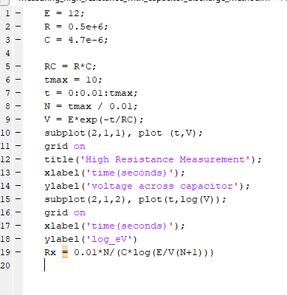

Output :

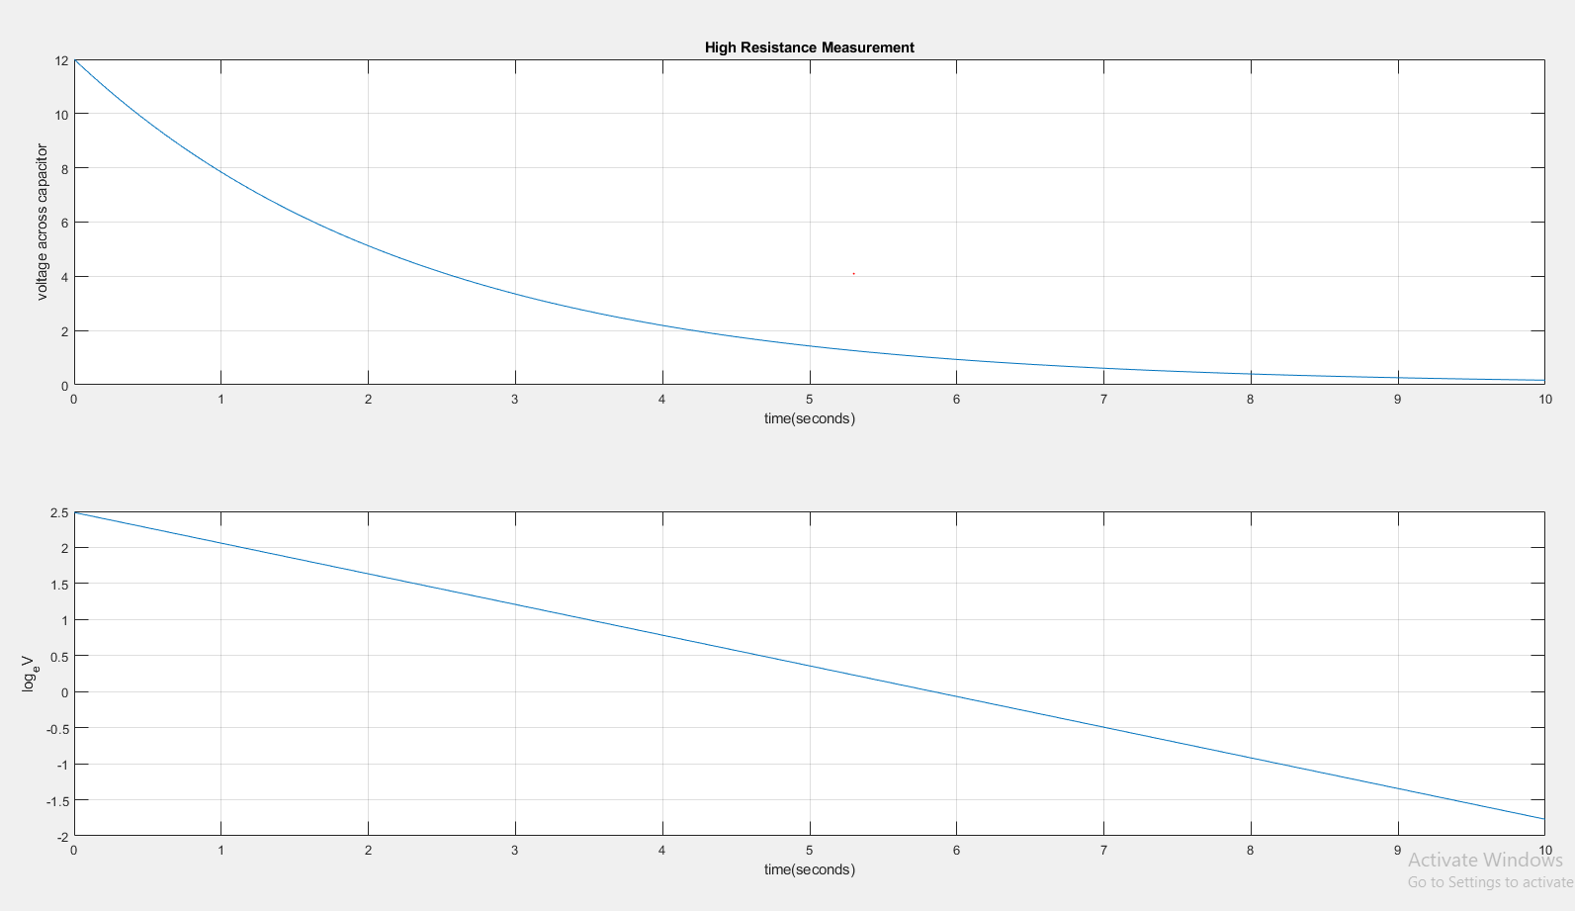

# Alternative method Matlab code :

Code :

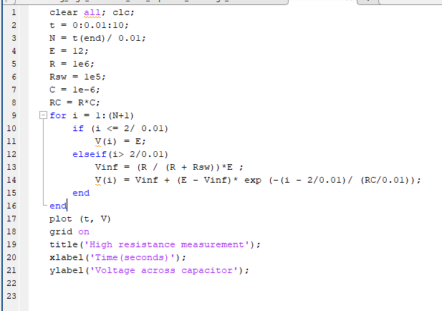

Output :

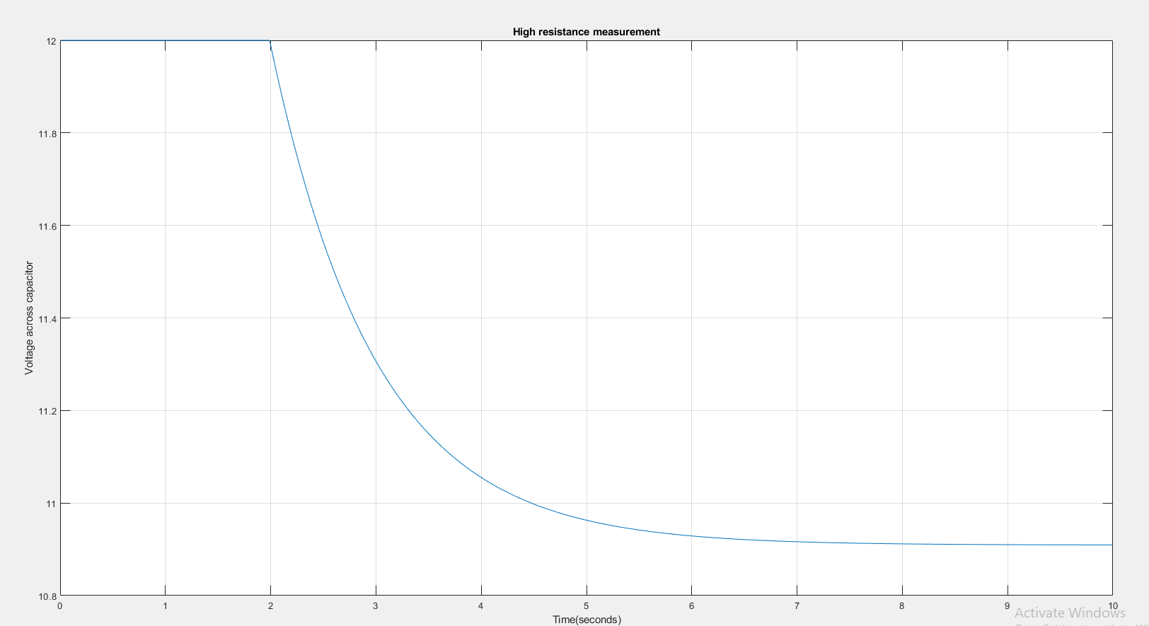

Discussion :

Observing the voltage discharge through the tinkercad oscilloscope was difficult and somewhat inaccurate. In order to make the process more convenient, as the circuits with greater capacitor values and the circuits with greater resistance values require more time to descend, and discharge, the readings were taken longer than 10s to improve the accuracy of the system.